Data Processing Manual

**Step 0**

Before getting started, you will need to have the raw data files, the behavior codebook csv, and the bottle rejectors file in your current directory.

**Step 1**

Download the Excel files containing the specified raw data from Dropbox.

**Step 2**

Create a new R Markdown file and save it under the name “#moB-data.Rmd” where # is the monthly data. Put this markdown file in the same location where you stored the raw data from Step 1 and the other files from Step 0.

**Step 3**

It is sufficient to copy and paste the cells from a previous data processing (example// 4moB-data.Rmd). However, there are small issues that you will have to look out for. These issues are listed below with accompanying screenshots.

* Issue 1
  + 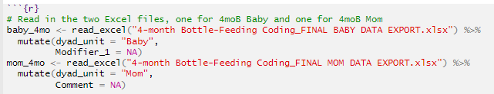
  + You will need to change the names of the excel files when reading in the data. Make sure to rename the dataset names to the appropriate month.
* Issue 2
  + 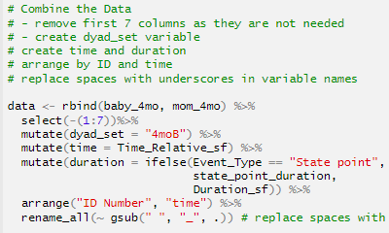
  + For the past few datasets (4moB, 6moB), it was sufficient to simply remove the columns from 1 to 7 as indicated by *select(-(1:7))*. Make sure to double check that this will work for future datasets.
  + Make sure to change *“4moB”* to the appropriate month.
* Issue 3
  + 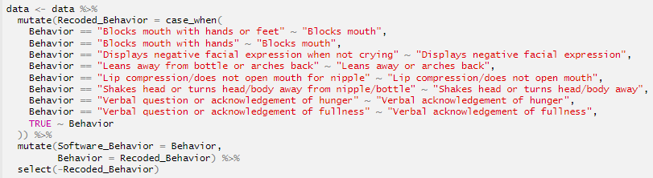
  + This was used to rename behaviors into smaller categories. So far these are all the behaviors that are being compressed, but it would be best to check if there are any more.
* Issue 4
  + 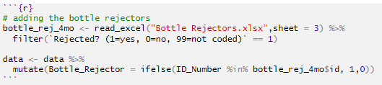
  + When the Bottle Rejectors are ready, make sure you are reading the correct sheet for the corresponding month (example// sheet 3 = 4mob, sheet 4 = 6moB).
  + Again, make sure the variables are named after the appropriate month.

**Step 4**

Run this code next to make sure that the first behavior of each mom for each ID is “Bottle not in mouth.” This code will produce 0 rows if it is valid. Otherwise, it will print the rows and the behaviors that starts the feeding period. If there are invalid rows, report them to Dr. Ventura so she can check them and make adjustments if necessary.

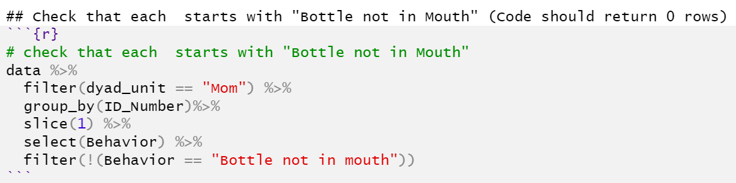

**Step 5**

Then, run the following chunks of code for additional checks. These check that each state start has a state stop and that the behaviors are coded correctly for mom and baby. The first code chunk should return 0 rows if it is valid. The second code chunk should return the behaviors matched up with the dyad unit.

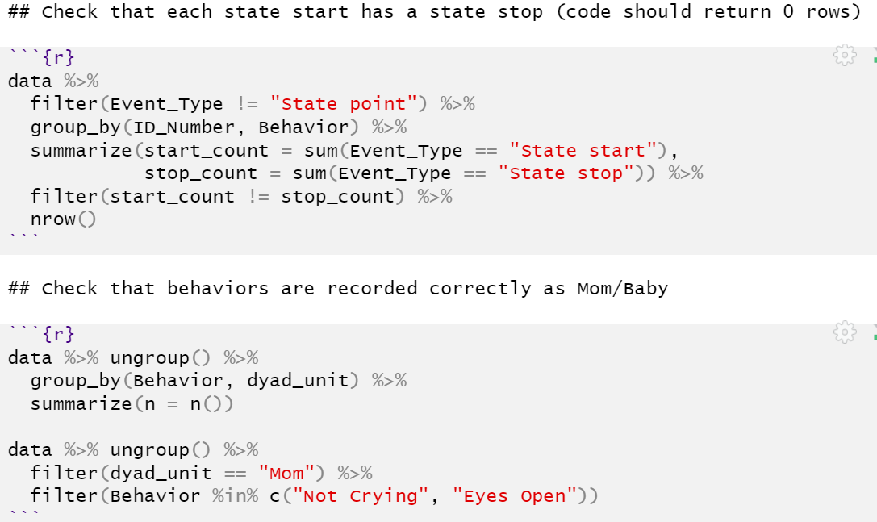

**Step 6**

Open up the markdown file, creating-all-data.Rmd. Read in the csv of the new dataset. Add it into the rbind function and then then run the write.csv function to create the all_data dataset.

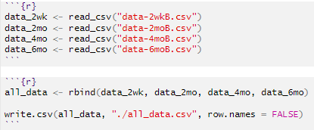

**Step 7**

Run the R markdown file called, incompatible_check.Rmd to check for any incompatible behaviors. This code checks for when certain Behaviors should not occur together (Right now, the incompatible behaviors it is checking for are “Push Nipple Out & Bottle Not in Mouth,” “Lip Compression & Bottle in Mouth,” and “Blocks Mouth & Bottle in Mouth”). This file reshapes the data to where each behavior is a column and if it is active, then it is indicated by a 1; otherwise, it’s a 0. This file reads in all_data.csv and checks the data for the instances listed above. It is common to find incompatible instances in new data. If there are incompatible instances, download the csv file that is created at the end of this markdown and let Dr. Ventura know so she can check these and make adjustments.

**Step 8**

Run the creating-quarterly-data.Rmd file. This file creates the columns Quarter and Half in the data. Using this data, you can look at sections of the feeding periods. The quarterly-feeding-summary.Rmd file in the Analysis Code folder in Dropbox will need this step to run.

**Step 9**

After all the checks are valid, upload the updated data sets (the new individual data set for the specific month and the all_data.csv) into the appropriate folders in Dropbox.